I use the quantity of inland port berths and coastal port berths in 2005-2014 and the average number of inland and coastal cities in 2009-2014 to do the visualization.



First of all, I use the average data in 2009-2014 to do a horizontal analysis .I set blue color for costal port and orange for inland port. And the circle size represent the quantity of berth(including the production and non- production berth) in that port. When the button click the location of that port, another bar chart will show the quantity of production port and non-production port. And I find when clicking the inland port ,the quantity of non-production berth is larger than the quantity of production port. And the quantity of production berth is larger than that of non- production berth in coastal port.





And the pie chart shows the same law.

Non-production ports account for a high proportion in inland port ,production port accounted for a high proportion in coastal city.

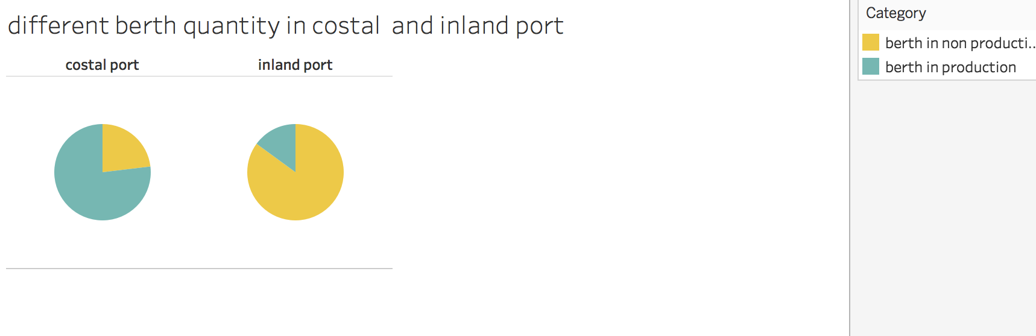

And I use highchart charset to show the change of quantity of berth in these ports,I find that almost every port shows a rising trend in these 10 years.



I also do the visualization of the change of volume of carrying capacity in inland and coastal ports.

I find that both in inland and costal port , the volume of carrying capacity is rising .And the volume of carrying capacity in costal port is almost twice of that in inland port. The volume of carrying capacity in inland port is higher than it following years In 2007 and 2008. The tourist transportation during 008 Olympic may cause the increase.

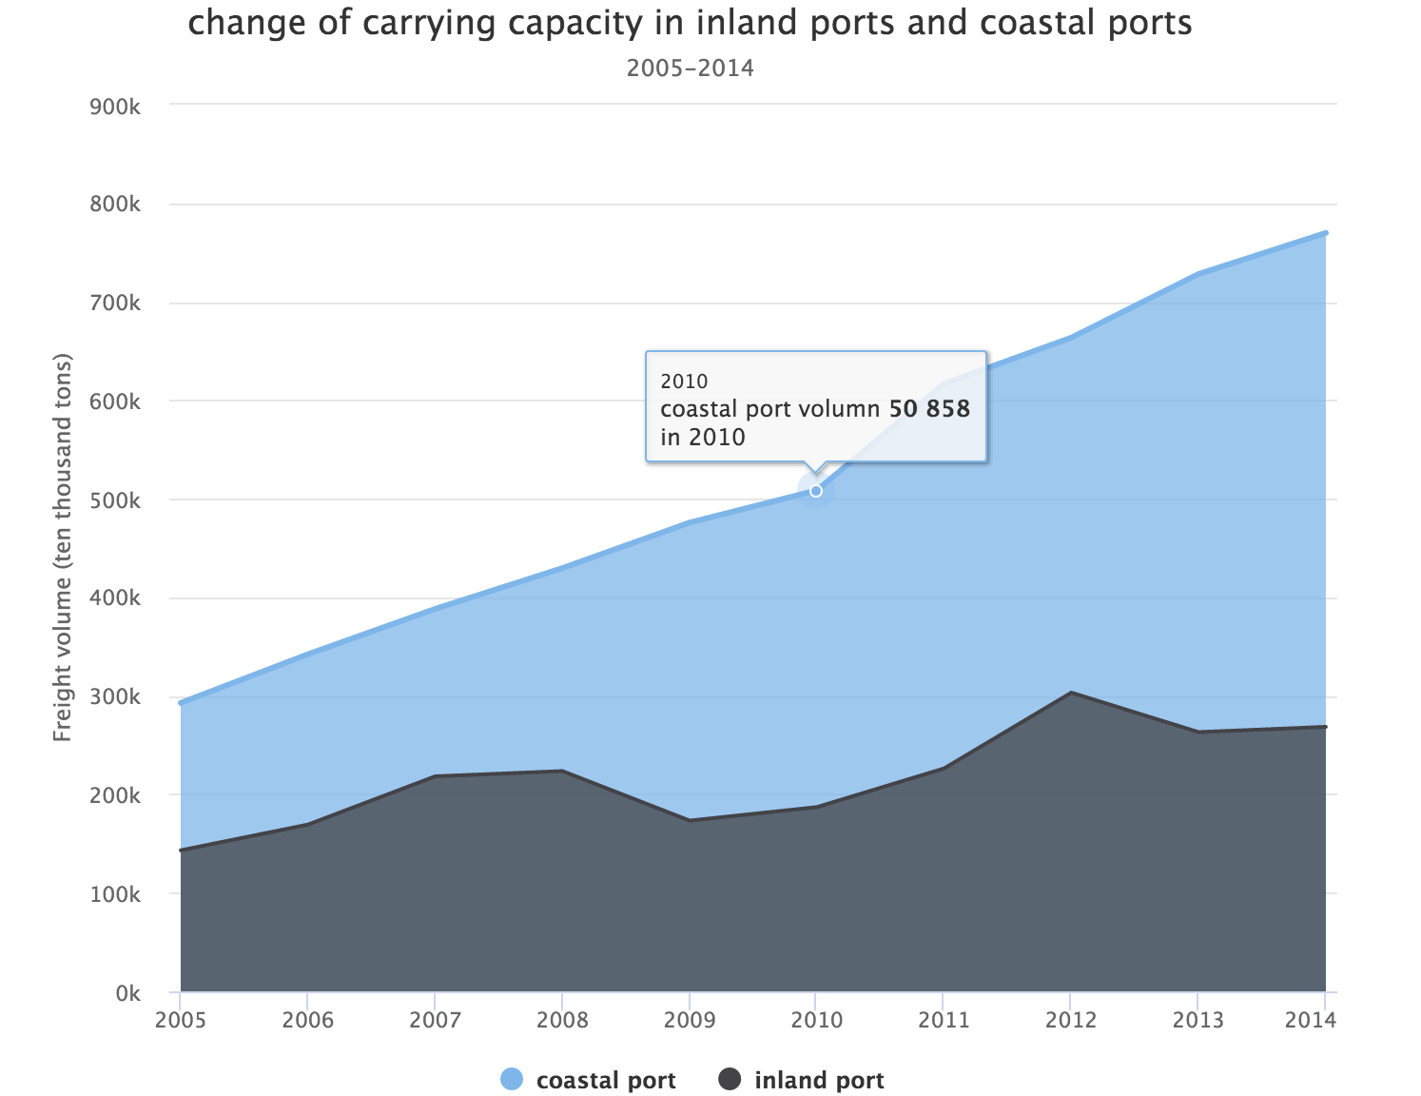

And I contrast the costal berth quantity and inland berth quantity , the line shows the costal berth percent .It shows that the percent of costal berth percent is around 50 percent and it shows a rising trend. Both the inland berth quantity and the coastal berth quantity increase with time.



So the conclusion is inland ports are mainly for non-production use , like tourist transportation .And the costal ports are mainly for production use ,such as transporting the production goods.

And the quantity of berth is show a rising trend ,with the increase of GDP and the development of productive force .The quantity of berth used for production increases faster.

I think the amount of berth will increase and the percent of production berth will also be high in the coming years.

I use tableau and the highchart charset to accomplish the graph.

What I think is poor is that my dataset is single . And the graph cannot integrate well.

I wanted to show the amount of production berth and non-production berth in every port in evert year But I find it is too cumbersome and it does not help the visualization and conclusion.